Susquehanna Valley Homeschool
Diploma Program, Inc.
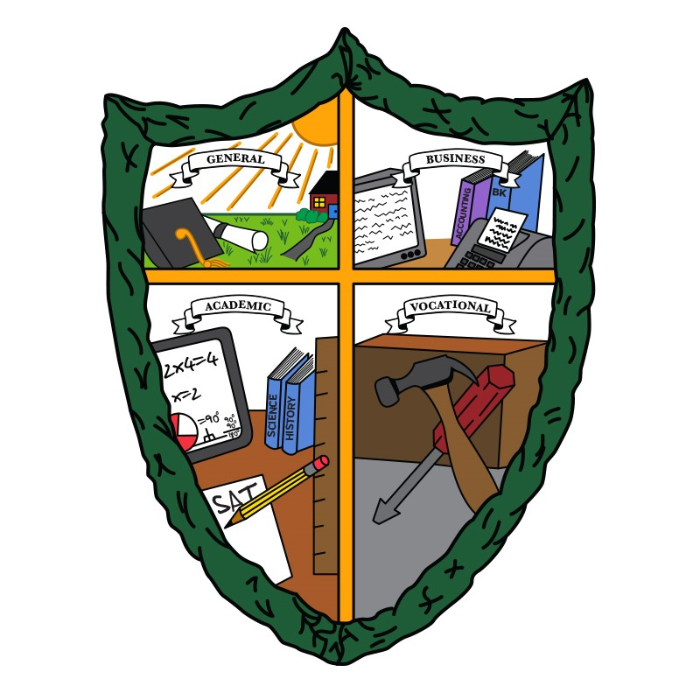

2026 Diploma Guide

 | Table of Contents.
1. | Purpose of homeschool education/SVHDP | Page 2
2. | Course requirements and options | Page 3-4
3. | Evaluations and Evaluators | Page 4
4. | Transfer of Credits, How Credits are awarded, Special Provisions | Page 4-5
5. | Fees | Page 5
6. | Basics of each diploma
 | A. General Diploma | Page 5-7
 | B. Academic Diploma | Page 7-8
 | C. Vocational-Technical Diploma | Page 9-10
 | Vo-Tech Clusters | Page 10
 | D. Business Diploma | Page 11-12
7. | Transcript/Diploma Filing form | Page 13
8. | Final Summary | Page 14-15
9. | Transcript Request Form | Page 16
10. General, Business & Vocational Technical Diploma Checklist |  | Page 17-18
11. Academic Diploma Checklist |  | Page 19-20
12. Blank Transcript of High School Records |  | Last page

Updated download version of this guide is available on the website: svhomeschool.org

1
PURPOSE OF HOMESCHOOL EDUCATION & SVHDP

- God-directed and parent-supervised homeschool education prepare students for responsible adult life by attending to their spiritual as well as intellectual and developmental needs. By challenging the student to achieve at their highest level possible, he/she will establish a firm foundation to attain their goals.

In conjunction with their families, churches, and community institutions, homeschool education prepares students to become lifelong learners and responsible, involved adults.

- Together with parents, families, and churches as well as community institutions, homeschool education provides opportunities for students to (1) develop godly character, (2) acquire knowledge and skills, (3) think critically, and (4) work cooperatively as well as independently.

- Home-based schools provide instruction throughout the required years of schooling with individually chosen curricula so that students may develop knowledge and skills in the following areas:

  - Reading, writing, and speaking.

  - Mathematics

  - Science.

  - Social Studies.

  - Arts and humanities.

  - Career education and work.

  - Family and consumer science.

  - Health and physical education.

The Susquehanna Valley Homeschool Diploma Program (SVHDP) was developed for the purpose of
providing a high school diploma that satisfies or exceeds the standards established in the statues of

Pennsylvania’s Law.

The SVHDP offers four diploma options to Pennsylvania residents. The General Diploma is granted to any student who has completed the basic requirements of the law and has evaluator letters to confirm this fact.
The Vocational Technical Diploma and Business Diploma are earned by a student who completes the basic requirements and prescribed courses in their specialized area of study. The Academic Diploma is granted to those students who wish to continue in higher education and meet those specific requirements outlined.

We expect high school students to take full responsibility for their own education with guidance from their parents/supervisors. The student will get out of his/her education what he/she puts into it. These are minimum requirements for graduation. However, we expect many students to exceed these requirements. This effort can truly pave the way for what will be a lifetime of learning.

Graduation exercises planned by SVHDP will be instituted once a year; at the end of the spring semester (July). Students can complete graduation requirements at the end of the fall semester and receive a diploma. They can participate in the graduation exercises at the end of the spring semester, if desired. If a family prefers a smaller, more intimate ceremony instead, they may choose to hold individual graduations on their own. All diplomas are sent out after the graduation date to those not participating in the ceremony. Diploma covers will be made available to those who are planning private ceremonies.

2
These minimum requirements necessary to graduate from a homeschool education program include completion of the following:

1. Four years of English
2. Three years of mathematics (must be three different courses of study)
3. Three years of science (must be three different courses of study)
4. Three years of social studies (must be three different courses of study)
5. Two years of arts and humanities.

 | The law also requires that the following areas must be covered in some way at the secondary level
(7 through 12):
 |  | Geography | Civics
 |  | World History | U.S. and Pennsylvania History
 |  | General Mathematics | Algebra
 |  | Geometry | Music
 |  | Art | Physical Education
 |  | Safety Education, including fire safety | Health and physiology

The law does not stipulate how much of each subject must be covered. The individual subjects could be taken as a credit, with the proper amount of study, and would be listed for credit on the transcript. For example - U.S. History (including geography). Subjects may also be covered in seventh or eighth grade with evaluator verification, but will not appear on the transcript.

COURSE REQUIREMENTS AND OPTIONS

At the secondary school level, the following course may be taught to fulfill credit requirements.

(Note: When a student has completed the requirements for one year’s work, he/she is finished with that course even if it does not take him/her a full calendar year to complete it.):

  - English: requirements include integrated reading (literature), composition, listening, speech, literature, and grammar (All of these areas must be covered).
  - Mathematics: options can include general mathematics, business mathematics, consumer mathematics, algebra, geometry, trigonometry, calculus, and computer science. (Problem-solving and reasoning being key components to the courses covered).
  - Science: options include astronomy, biology, chemistry, ecology, earth science, general science, geology, physical science, psychology, and physics. Biology, chemistry, and physics are called “laboratory sciences” and should have a hands-on component.
  - Social studies: options can include anthropology, culture studies, geography, ancient and world history, U.S. and PA history, modern history, political science, and sociology.
  - Arts and humanities: options can include art history, Bible, theology, foreign languages, visual arts, music, music history, music theory, dance, theater arts, film studies, practical arts and crafts.
  - Health and physical fitness: options include a study of family and community health and safety, nutrition, and physical fitness. (Including instruction every year about the prevention of alcohol, chemical, and tobacco abuse.)

3

The following additional courses of study can be applicable to all students and are recommended courses of study.

- Career education and work: options include hands-on learning of skills in entrepreneurial settings, on-the-job training, introduction to developing job-seeking and job-retaining skills, and for

students completing vocational technical programs, the skills to succeed in the occupation

for which they are being prepared. Driver’s education is recommended for age-appropriate students.

- Family and consumer science: options include home management, basic knowledge of child health, and child care skills.

Evaluations:

A student must have four evaluations or evaluations combined with transcripts from public or private schools. If a student is planning to complete high school in less than four years, he/she will need a mid-year evaluation to establish compliance with all requirements. This will allow graduations to occur twice a year instead of the usual once in June. These evaluations must accompany the student’s transcript to receive a diploma.

Evaluators:

Each evaluator who wishes to be recognized by SVHDP shall have two years of work experience in evaluating secondary level, OR two years of experience as the supervisor of a secondary level home education program, OR be a certified teacher at the secondary level. All those wishing to be evaluators must be interviewed and approved by the SVHDP Board of Directors. To begin this process, an evaluator should send a resume, teaching certificate (if applicable), and child abuse clearances to the SVHDP with a request for an interview. The evaluator will be contacted in order to arrange a meeting time.

Transfer of Credits:

We accept transfer credits. If a student transfers to home education from a school, credit for school courses completed will be accepted by the SVHDP upon receipt of the school transcript. Where homeschoolers have not kept good documentation in the past, the evaluators, at their discretion, may accept credits for the previous schooling completed based upon interviews with the parent and student. Likewise, those students who transfer from out of state must supply documentation of credits that may be accepted, at the discretion of the evaluator.

How Credits are Awarded:

Supervisors of home education programs (parents) award credits to their children. Upon evaluation and interviewing, the qualified secondary education evaluator who has agreed in writing to our standards and has filed his/her credentials with us, accepts those credits by completing and signing his/her name on the SVHDP transcript forms. Those credits are then accepted by and filed with the program.

4
Provisions for Students with Disabilities:

SVHDP shall award diplomas to home-educated students with disabilities who are achieving up to their potential. Any of the requirements listed may be waived by the evaluator if he/she deems them inappropriate for a student with disabilities, and if the evaluator mentions, in the evaluation letter, that the student is disabled.

Students Exceeding Compulsory School Age:

*IMPORTANT CHANGE

FOR ALL STUDENTS WISHING TO RECEIVE A SVHDP DIPLOMA

There is a change to the requirements for Pennsylvania students who are above the compulsory school age (17-21).

* In June of 2008, SVHDP and all other diploma programs in the State of PA received an email and letter
from the PA Department of Education, any student who turns 18 must continue filing an affidavit even if they are in a PA State approved diploma program.

If you have concerns or questions about the new mandate or problems with your school district accepting an affidavit, don't hesitate to get in touch with Amy Reese at amyreese@ptd.net, Anjie at mamavago@aol.com , or Linda Blocker at cablocker@verizon.net. Please note that students over the age of 21 are not eligible to receive an SVHDP Diploma (law 24P.S. 13-1301). This was not clearly stated in our diploma guides previously.

Suppose a student is beyond the compulsory school age and still wants to receive a diploma. In that case, he/she must complete the time required and requirements for each unit credit, including evaluations, writing requirements, and keeping a log and portfolio.

We charge the following fees:

- $45.00 (if not participating in the graduation ceremony) Transcript Filing/Diploma fee payable before the unsigned but numbered diploma is sent to the family. This includes transcript review, diploma, diploma cover, and tassel for the graduate.

- $65.00 (if participating in the graduation ceremony) This includes the above plus the venue.

- $5.00 Transcript fee payable each time a request is made to send a copy of the transcript to the student.

Please note the above fees are subject to change without notice in order to keep up with rising costs.

*STANDARDS FOR THE GENERAL DIPLOMA *

After meeting the graduation requirements of 15 credits, no additional credits are needed for a General Diploma. The following guidelines must be used to determine if credits will be issued for this diploma.

General Diploma English: The four years of English must include literature, composition, language and

speech as follows:

1. Literature - For each school year, the student will read or listen to a variety of age/grade appropriate books. A book list of all the books read each year must be kept. This list is especially important if you are not using a literature text.

5

- Composition and Language - For each school year, the student must demonstrate improvement in composition and language skills by writing at least five pages of composition work as evidence of completion of the composition requirements. Rough drafts showing corrections for punctuation, spelling, and/or grammatical error will be accepted to satisfy the language requirements. Alternatively, the language requirement may be met through completion of over 1/4 of a language or grammar textbook or at least 30 logged entries in language or grammar study.

- Speech, Visual communications/Performance - The student must give at least one speech or its equivalent in performance (musical theater, sign language-interpreting or performing, instructing/demonstrating, mime, magic presentation, etc.) during the year to a group outside of the immediate family. Any one of the following will be accepted as proof that the student has met this requirement.

  - Notes which the student used when giving the speech, etc.

  - Recognition from those who heard the speech or viewed the performance.

  - A description of the speech or performance, written by the student or parent.

  - Photographs of the student making a speech or performing in a play.

- Sign Language - The student may receive a partial or full English credit if a sign language course of study is taken during the year. This would include textbook use, learning American Sign Language (ASL) - its structure, including idioms and cultural aspects, as well as experience with ASL.

General Diploma Mathematics: The three years of mathematics can include basic mathematics, problem-solving, mathematical reasoning, algebra, and geometry. Any of the following alternatives will be accepted as evidence of completion of one year’s credit for this course of study.
- Completion of over three-fourths of a textbook as long as it is designed as a full year credit textbook.

- Any combination of textbook pages and daily logged entries describing the activities related to the course content, totaling 120 entries.

- Logged entries of at least 120 entries and/or activities related to the course content.

- Completion of a college course.

- Passing test score on an Advanced Placement exam (i.e. 3 points out of a possible 5).

General Diploma Science: The three years of science can include: laboratory science (biology, chemistry, physics), life science, earth and space sciences, environmental sciences, chemical sciences, physical sciences, information sciences, allied health science, psychology, and agricultural sciences. Any one of the following alternatives will be accepted as evidence of completion of one year’s credit for these courses of study.

- Completion of over three-fourths of a textbook as long as it is designed as a full year credit textbook.

- Any combination of textbook pages and daily logged entries describing the activities related to the course content, totaling 120 entries.

- Logged entries of at least 120 entries and/or activities related to the course content.

- Completion of a research paper of at least 10 pages (typed 12 font doubled spaced) in length which demonstrates learning of a subject and includes the student’s own conclusions based upon his research using no less than three resources other than an encyclopedia (Minimum 120 hours of work).

- A 30-minute speech presented to a group outside of the immediate family. This speech should demonstrate an understanding of the subject and conclusions drawn by the student from his/her study.
- Completion of a college course.

- Passing test score on an Advanced Placement exam.

6
General Diploma Social Studies: The three years of social studies can include the history of the United States and Pennsylvania, anthropology, ancient history, world history, multi-cultural studies, geography, civics and economics, political science, and sociology. Any one of the following alternatives will be accepted as evidence of completion of one year’s credit for these courses of study. The same alternatives as described for the General Diploma Science will be accepted as evidence of completion of one year’s credit for this course of study.

General Diploma Arts and Humanities: The two years of arts and humanities can include art history, Bible studies, dance, visual arts, foreign languages, music history, music theory, practical arts and crafts, and theater. The same alternatives as described for the General Diploma Science will be accepted as evidence of completion of one year’s credit for this course of study.

*STANDARDS FOR THE ACADEMIC DIPLOMA *

Fifteen credits, as stated in Pennsylvania’s education law, are required for a student to receive the Academic Diploma. The following guidelines must be used to determine if credits will be issued for this diploma.

Academic Diploma English: The four years of English must each include literature, composition, language, and speech as follows:

1. Literature - For each school year, the student will read or listen to at least fifteen age-appropriate books in any subject area, fiction or non-fiction, including one classic. At the discretion of the evaluator, the quality and length of books may be considered acceptable for credit if the quantity requirement is not met. The Bible is considered a classic.
2. Composition and Language - For each school year the student must demonstrate improvement in composition and language skills by writing three compositions, one of which is a longer composition of at least 5 pages (typed 12 font double spaced) using no less than three resources other than an encyclopedia. In order to satisfy the language requirement, rough drafts which show corrections for punctuation, usage, and/or grammatical errors made during the writing process will be accepted. Alternatively, the language requirement may be met through completion of over 1/4 of a language or grammar textbook or at least 30 entries of work in language of grammar study.
3. Speech, Visual communication/Performance - The student must give at least one speech or

its equivalent in performance (musical theater, sign language (interpreting or performing), instructing/ demonstrating, mime, magic presentation, etc.) during the year to a group outside of the immediate family. Any one of the following will be accepted as proof that the student has met this requirement:

A. Notes which the student used when giving the speech, demonstration/instruction,
B. Recognition from those who heard the speech or viewed the performance,

C. A description of the speech or performance, written by the student or parent, or
D. Photographs of the student making the speech or performing in a play.

4. Or one of the following alternatives will be accepted for one credit:

Sign Language - The student may receive a partial or full English credit if a sign language course of study is taken during the given year. This would include textbook use, learning of American Sign Language (ASL), its structure including idioms and cultural aspects as well as experience with ASL.

- Complete a College course.

- Passed Advanced Placement Exam (AP, not CLEP)

7
Academic Diploma Mathematics: The three years of mathematics include problem-solving, mathematical reasoning, algebra I and II, geometry, trigonometry calculus, consumer math, analysis skills, etc. Any one of the following alternatives will be accepted as evidence of completion of one year’s credit for this course of study.

- Completion of over three-fourths of a textbook, as long as it is designed as a full year credit textbook.

- Any combination of textbook pages and daily logged entries describing the activities related to the course content totaling 120 entries.

- Logged entries of at least 120 entries and/or activities related to the course content.

- Completion of a college course.

- Passing test score on an Advanced Placement exam (AP, not CLEP).

Note: The student must take one year of algebra or one year of geometry or ½ year of both as part of the three mathematics courses required to receive an academic diploma.

Academic Diploma Science: The three years of science must include: at least one hands-on laboratory science to include 6 labs with lab reports (biology, chemistry, physics), life sciences, earth and space sciences, environmental sciences, chemical sciences, physical sciences, psychology, information sciences, and agricultural sciences. Any one alternative will be accepted as evidence of completion of one year’s credit for this course of study.

- Completion of over three-fourths of a textbook as long as it is designed as a full year credit textbook.

- Any combination of textbook pages and daily logged entries describing the activities related to the course content totaling 120 entries.

- Logged entries of at least 120 entries and/or activities related to the course content.

- Completion of a research paper of at least 10 pages in length (typed 12 font double spaced), which demonstrates learning of a subject and includes the student’s own conclusions based upon his research using at least three resources other than an encyclopedia (Minimum of 120 hours).

- 30-minute speech presented to a group outside of the immediate family. This speech should demonstrate an understanding of the subject and conclusions drawn by the student from his study.
- Completion of a college course.

- Passing test score on an Advanced Placement exam (AP, not CLEP).

Academic Diploma Social Studies: The three years of social studies can include the history of the United States and Pennsylvania, anthropology, ancient and world history, multi-cultural studies, geography, civics and economics, political science, and sociology. The same alternatives as described for the Academic Diploma Science will be accepted as evidence of completion of one year’s credit for this course of study.

Academic Diploma Humanities and Fine Arts: The two years of arts and humanities can include art history, Bible studies, dance, visual arts, foreign languages, music history, music theory, practical arts and crafts, and theater. The same alternatives as described for the Academic Diploma Science will be accepted as evidence of completion of one year’s credit for this course of study.

Note: These are minimum requirements. Students who plan to further their education should visit the website or contact the registrar from the college or university in which they are interested in attending in order to determine their requirements for a specific program of study during high school.

8
*STANDARDS FOR THE VOCATIONAL-TECHNICAL DIPLOMA*

While meeting the graduation requirements of 15 credits as stated in the Pennsylvania education law, students will integrate academic subjects and vocational studies. This will ensure a relevant and meaningful educational program. Both academic and vocational achievement will be monitored as necessary within the cluster. Competency in a certain skill area must be shown before advancement. Progress can be made either individually or within a group.

Specific subjects to be covered within each cluster will be unique to that cluster. Math, science, etc.; will be chosen pertaining to the specific requirements of the field of study. Once meeting the graduation requirements, no additional credits are needed. The following guidelines must be used to determine if credits will be issued for this diploma.

Vocational-Technical Diploma English: The four years of English must include literature, composition, language, and speech, with possibilities as follows:

Study skills - use of the dictionary and research materials

Basic writing skills - research papers, technical reports, book reports, proposals, job estimates, resumes, business letters, as well as, creative writing (i.e., short stories, poetry, etc.)

Grammar - correction of writing projects.
Literature – any reading materials, fiction or non-fiction, related to your vocational training and growth.

Vocational-Technical Diploma Mathematics: The three years of mathematics should include math pertaining to the individual field of study, with possibilities of Algebra I and II (as related to the specific area of technology), Geometry, Trigonometry, Consumer Math, Analysis skills, etc... Any one of the following will be accepted as evidence of one year’s credit for this course of study.

- Completion of over three-fourths of a textbook.

- Any combination of textbook pages and daily logged entries describing the activities related to course content totaling 120 entries

- Logged entries of at least 120 entries and/or activities related to the course content.

- Completion of a college course.

- Passing test score on an Advanced Placement exam (AP not CLEP).

Vocational-Technical Diploma Science: The three years of science should include sciences pertaining to the individual field of study, with possibilities of biology, chemistry, environmental science, physics, space science, electronics, agriculture, computer science, and medical science, etc…

Any one of the following will be accepted as evidence of one year’s credit for this course of study.

- Completion of over three-fourths of a textbook.

- Any combination of textbook pages and daily logged entries describing the activities related to course content totaling 120 entries.

- Logged entries of at least 120 entries and/or activities related to the course content.

- Completion of a research paper of at least 10 pages in length (typed 12 font double spaced) which demonstrates learning of a subject and includes student’s own conclusions based upon his research using at least three sources other than an encyclopedia (Minimum of 120 hours of work).

- A 30-minute speech presented to a group outside of the immediate family. This speech should demonstrate an understanding of the subject and conclusions drawn by the student from his study.

- Completion of a college course.

- Passing test score on an Advanced Placement exam (AP not CLEP).

9
Vocational-Technical Diploma Social Studies: The three years of social studies should include studies pertaining to the individual field of study. The same alternatives as described for the science credit will be accepted as evidence of completion of one year’s credit for this course of study.

Vocational-Technical Diploma Arts and Humanities: The two years of study in this area may also pertain to the individual field of study, offering many possibilities to explore the student’s interests. The same alternatives as described for the science credit will be accepted as evidence of completion of one year’s credit for this course of study.

***Graduation Requirements: When the courses required by Pennsylvania law have been met, a final project must be completed in order to receive a Vocational-Technical diploma.
The student must complete a project in one or more areas of concentrated study under the guidance of the homeschool supervisor/instructor. The purpose of the final project, which may include research, writing, or some other appropriate form of demonstration, is to establish that the student is able to apply, evaluate, and integrate the information learned and to effectively communicate with substantial knowledge and understanding. This project may be completed by the individual student or a group of students.

Vocational-Technical Clusters

1. Technical Cluster 2. Construction Cluster

-Electronic technology -Carpentry

-Computer technology -Masonry

-Engineering -Electrical construction & maintenance

-Health/Medical assistant/EMT -Building construction & maintenance

-Para-Legal -Heating, ventilation, air-conditioning

-Surveying -Welding

-Drafting and design technology -Construction inspection

-Law enforcement training
-Firefighter training
-Scientific data processing technology

3. Communications & transportation cluster 4. Service Cluster

-Precision metalworking -Child care assistant

-Automotive technology -Teachers’ aide

-Outdoor power equipment technology -Cosmetology

-Commercial art -Food production, management

-Graphic art -Marketing and distribution

-Advertising -Horticulture and landscaping

-Diesel technology -Missions preparation

-Precision machine technology

5. Miscellaneous

-Agriculture

-Performing arts

-Forestry

-Wildlife commission worker

-Veterinarian assistant

10

*STANDARDS FOR THE BUSINESS DIPLOMA*

While meeting the graduation requirements of 15 credits as stated in the Pennsylvania education law students will integrate academic subjects and business studies. This will ensure a relevant and meaningful educational program.
Specific subjects to be covered will be chosen pertaining to a business curriculum. Achievement will be monitored and can be made either individually or within a group setting.

Once meeting the graduation requirements, no additional credits are needed. The following guidelines must be used to determine if credits will be issued for this diploma.

Business Diploma English: The four years of English must include literature, composition, language, and speech, to be integrated with specific areas of instruction such as;

Study skills including the use of dictionary and research materials,

Basic writing skills (research papers, resumes, business letters, etc.), as well as creative writing (short stories, poetry, etc.),

Grammar, Communication skills, Book reports, Shorthand/Computer note hand Word processing and desktop publishing, Spreadsheets/Databases

Business Diploma Mathematics: The three years of mathematics should include math pertaining to business, with possibilities of bookkeeping, accounting I and II, business math, algebra I and II (as related to business use), applied mathematics, etc… Any one of the following will be accepted as evidence of one year’s credit for this course of study.

- Completion of over three-fourths of a textbook.

- Any combination of textbook pages and daily logged entries describing the activities related to course content totaling 120 entries.

- Logged entries of at least 120 entries of study and/or activities related to the course content.

- Completion of a college course.

- Passing test score on an Advanced Placement exam (AP not CLEP).

**Note: The student must take one year of either bookkeeping OR accounting as part of the three mathematics courses required to receive a Business diploma.

11
*SUGGESTIONS OF STUDY TOPICS FOR BUSINESS DIPLOMA*

ENGLISH AND MATHEMATICS

Dictionary and research materials |  |  |  |  |  | Taxes-Federal, State, local
Research papers |  |  |  |  |  | Union dues logs
Resumes |  |  |  |  |  | Accounts payable
Business letters |  |  |  |  |  | Accounts receivable
Book reports |  |  |  |  |  | Accruals
Word processing |  |  |  |  |  | Order entry
Desktop publishing |  |  |  |  |  | Medical Benefit programs
Shorthand/Computer note hand |  |  |  |  |  | Product knowledge
Spreadsheets/databases |  |  |  |  |  | Marketing
Telephone procedures |  |  |  |  |  | Advertising
Customer relations/service |  |  |  |  |  | Retail vs. Wholesale
Payroll |  |  |  |  |  | Computer skills

Business Diploma Science: The three years of science should include sciences pertaining to business, with possibilities of computer science, basic programming, advanced programming, etc. Any one of the following alternatives will be accepted as evidence of one year’s credit for this course of study:

- Completion of over three-fourths of a textbook.

- Any combination of textbook pages and daily logged entries describing the activities related to course content totaling 120 study entries.
- Logged entries of at least 120 entries and/or activities related to the course content.

- Completion of a research paper of at least 10 pages in length (typed 12 font double-spaced) which demonstrates learning of a subject and includes the student’s own conclusions based upon his research using at least three sources other than an encyclopedia (Minimum of 120 hours of work)

- A 30-minute speech presented to a group outside of the immediate family. This speech should demonstrate an understanding of the subject and conclusions drawn by the student from his study.
- Completion of a college course.

- Passing test score on an Advanced Placement exam (AP not CLEP).

Business Diploma Social Studies: The three years of social studies should include studies pertaining to business, with possibilities of marketing, entrepreneurship, business law, advertising, etc. The same alternatives as described for the Science credit will be accepted as evidence of completion of one year’s credit for this course of study.

Business Diploma Arts and Humanities: The two years of study in this area may also pertain to business, offering many possibilities to explore the student’s interests. Keyboarding or basic typing and MIDI could be included here. The same alternatives as described for the science credit will be accepted as evidence of completion of one year’s credit for this course of study.

***Graduation Requirements: When the courses required by Pennsylvania law have been met, a final project must be completed in order to receive a Business diploma.
The student must complete a project in one or more areas of concentrated study under the guidance of the homeschool supervisor/instructor. The purpose of the final project, which may include research, writing, or some other appropriate form of demonstration, is to establish that the student is able to apply, evaluate, and integrate the information learned and to effectively communicate with substantial knowledge and understanding. This project may be completed by the individual student or a group of students.

12

SVHDP – TRANSCRIPT/DIPLOMA FILING INFORMATION

We are very pleased that you have decided to file your transcript with the Susquehanna Valley Homeschool Diploma Program. The transcript filing/diploma fee is $45 (if not participating in graduation) and $65 (if participating). These fees must be paid by June 30th of the senior year (December 31st for January Graduation). The form will need to be sent in prior to this payment. We will not release any information to anyone (prospective colleges, employers, etc.) unless we receive a signed request from the student. There is a separate transcript fee of $5.00 per request. Please use the appropriate form. The official sealed transcript will be sent to the student which can then be forwarded to the organization.

DEADLINES FOR FILING: March 1st for the July graduation and December 1st for the January graduation. This applies to ALL students regardless of participation. If deadline is not met, fee is double, and diploma will be sent after the delayed processing (September for July Graduates, and March for January Graduates. Payment can be made at a later date, but must be received by June 30th for July Graduation and December 31st for January Graduation.

TRANSCRIPT/DIPLOMA FILING FORM

Date: ______________________________ I am filing a transcript for (Student’s Name) _____________________________________________

Graduation (circle one) January July Year ____________

______ Evaluations (completed to date) for High school credit and any public school transcripts (if applicable).

______ SVHDP Transcript of High School Record, with all/any credits from public or private schools added, and properly signed by
the supervisor and a qualified evaluator. If the transcript form is not properly and completely filled out, we may be
forced to delay issuing the diploma.

______ $45 filing/diploma fee (per student) $90 if filed after deadline, not participating in the ceremony.

______ $65 filing/diploma fee and graduation fee (per student) $110 if filed after deadline, participating in the ceremony.

Make checks payable to SVHDP and send to SVHDP, Linda Blocker, 5714 Potteiger Ave, Harrisburg, PA 17112.

_____ We have read the Susquehanna Valley Homeschool Diploma Program manual and we understand our responsibilities and privileges under this program.

Student’s Name as it should appear on the diploma: ________________________________________________________

(Please print clearly)

Diploma: (Circle one): Academic General Business Vocational __________________________(specify area)

Address: (please print): ___________________________________________________________________

Phone: ______________________________________Email: ________________________________________________
(print clearly for email confirmation of receipt)
Supervisor’s Signature: _______________________________________

Name & Phone # of Evaluator: ______________________________________________________________________

If participating – please send a short (100 word) bio so that it can be printed in the program and read at graduation.

Updated 2/26
13
Final Summary

Use the charts on the following pages to plan your four years and to check off items when completed, you may want to use pencil for course planning as your needs and desires may change.

Total Number of Credits:
 | Required Subjects |  | Total Credits |  |  | Completed(X) |  |  |  | Senior Projects*  (Vo Tech & Business)
 | English (4 credits)
 | Math (3 credits)
 | Science (3 credits)
 | Social Studies (3 credits)
 | Humanities (2 credits)
 | Electives

_____ You must have four evaluations or a combination of evaluations and transcripts from public or private school to equal four years of work.

_____ Transcripts must be completed and signed by the evaluator and parent and must be filed with SVHDP in order to receive a diploma.

_____ July Graduation (Form to be completed & sent by March 1st), regardless of whether or not your son/daughter will be participating in the graduation ceremony.

_____ January Graduation (Form to be completed & sent by December 1st), regardless of whether or not your
son/daughter will be participating in the graduation ceremony.

_____ If participating in the graduation, a short (100 word) biography of the student will be needed for the program. Please submit by June 30th or November 30th. If not received by these dates, we cannot guarantee that it will be placed in the program. Your cooperation in this matter is appreciated.

Packets will be sent to you containing graduation information (date, time, directions) when your student decides if he/she will be attending the graduation ceremony in Harrisburg (location may change depending upon availability). Please avoid last-minute decisions. We may not be able to accommodate your application request. Check our website for any updates or changes.

Please be sure to send the transcript filing form by the above date(s). All those students who send filing forms after the date specified must wait until the next graduation date. All diplomas for non-participating students will be mailed out after the graduation ceremony date.

14

Please make note: The following listed subjects must be covered sometime between grades 7 and 12. Check off those which you have completed.

X | Subject | X | Subject | X | Subject | X | Subject
 | Geography |  | Geometry |  | Civics |  | Safety/Fire Ed.
 | World History |  | Health/physiology |  | US & PA History |  | Phys. Ed.
 | General Math |  | Algebra |  | Music |  | Art

If at any time you have questions regarding the program, issuing of credit, or needing help with organizing your high school program, OR for those individuals who would like to speak at our graduations or have questions about transcripts, please feel free to contact:

Sandy Elliott: (717) 580-5206 (Especially for evaluators & questions about home school law). email: selliott095@gmail.com

For those evaluators who would like to be approved for this diploma program, please contact: Fran Lindsay: (717) 592-0073

email: aslan2fran@aol.com

If your student is planning on attending a college or university, it would be prudent for you to contact that institution and request an overview of their requirements for entry. Many institutions require more than 15 credits including several extracurricular activities listed on transcripts.

The following checklists on pages 17-20 are for your convenience. The transcript that is to be completed by your evaluator is on the last page. If the evaluator uses a not descriptive checklist style evaluation, please have them complete the checklist to be submitted with the evaluations and transcript.

For a list of the Board of Directors, please visit our website www.svhomeschool.org.

For a current list of evaluators, please go to our website www.svhomeschool.org. You may also download the necessary forms related to transcripts and graduation. Information about graduation will be posted including the date and time and directions to the graduation site.

May our Lord bless you abundantly in your pursuit of a better education.

15

REQUEST FOR OFFICIAL TRANSCRIPT

This form is designed to ensure that all pertinent information is provided, allowing us to process this request promptly. Upon receipt of this form and a check for $5.00, a sealed official transcript will be sent to your home stamped with our official seal and sealed in an envelope. You are to forward or hand-carry the transcripts (unopened) to the institution or organization requiring this document. Unfortunately, due to many institutions discarding the transcripts we have sent, we must mail this document directly to the student.
NEW: We can email an official transcript to an institution or employer. We would need the email address for the person receiving the transcript. The cost is $10, which includes a paper transcript sent to the student.

&____________________________________________________________________________
Susquehanna Valley Homeschool Diploma Program, Inc.
5714 Potteiger Ave.
Harrisburg, PA 17112

Request date: ____________

Student Name: ________________________________________________________________

Phone #: _________________________Student Email Address: __________________________

Date of Graduation (include year): ___________________________

Number of Paper Transcripts requested: _________ Email/Paper Transcripts requested: _________
(Please include the institutions emails below)
Enclosed is a check for $5.00 per paper or $10.00 per email/paper transcript.
Please send an official SVHDP transcript to:

Student’s Address: ____________________________________________________

____________________________________________________

____________________________________________________

Student Signature: ___________________________________

Print Name Clearly: _____________________________________

*Institutions' email address for electronic transcript: _______________________________
(Can not be the parent or student email address)

Official Use Only:

Date request received: ______________________Date transcript sent: _____________

Notes: _______________________________________________________________

16
General, Business & Vocational Technical Diploma

General, Business & Vocational Technical Checklist: ENGLISH

9 | 10 | 11 | 12 | The following items must be completed to receive credit for each year.
 |  |  |  | 1. Read or listen to age/grade appropriate books
 |  |  |  | 2. Write at least 5 pages of composition work
3. Keep rough drafts to show punctuation, usage &/or grammatical error corrections
or complete over ¼ of a language/grammar textbook, or at least 30 daily logged
entries of work in language grammar
4. Three-to-five-minute speech/demonstration given to those outside the immediate
family.
 |  |  |  | Or one of the following alternatives will be accepted for credit.
 |  |  |  | Complete an American Sign Language Course of study
 |  |  |  | Complete a college English course
 |  |  |  | Pass an Advanced Placement Exam (AP not CLEP)
 |  |  | General, Business & Vocational Technical Checklist: MATHEMATICS
9 | 10 | 11 | 12 | Any one alternative will be accepted for credit each year.
 |  |  |  | Complete over ¾ of a textbook
 |  |  |  | 120 logged entries
 |  |  |  | Combination of textbook pages & logged entries equal to 120 entries
 |  |  |  | College course
 |  |  |  | Passed Advanced Placement Exam (AP not CLEP)
 |  |  | General, Business & Vocational Technical Checklist: SCIENCE
9 | 10 | 11 | 12 | Any one alternative will be accepted for credit each year.
 |  |  |  | Complete over ¾ of a textbook
 |  |  |  | 120 logged entries
 |  |  |  | Combination of textbook pages & logged entries equal to 120 entries
10-page research paper, using a least 3 non-encyclopedia sources 12 count font,
double spaced (Minimum of 120 hours of work)
 |  |  |  | 30-minute speech/demonstration given to those outside the immediate family
 |  |  |  | College course
 |  |  |  | Passed Advanced Placement Exam (AP not CLEP)
 |  |  | 17
 |  |  |  | General, Business & Vocational Technical Checklist: SOCIAL STUDIES
9 | 10 | 11 | 12 | Any one alternative will be accepted for credit each year.
 |  |  |  | Complete over ¾ of a textbook
 |  |  |  | 120 logged entries
 |  |  |  | Combination of textbook pages & logged entries equal to 120 entries
10-page research paper, using a least 3 non-encyclopedia sources 12 count font,
double spaced (Minimum of 120 hours of work)
 |  |  |  | 30-minute speech/demonstration given to those outside the immediate family
 |  |  |  | College course
 |  |  |  | Passed Advanced Placement Exam (AP not CLEP)

 |  |  | General, Business & Vocational Technical Checklist: ARTS & HUMANITIES
9 | 10 | 11 | 12 | Any one alternative will be accepted for credit each year.
 |  |  |  | Complete over ¾ of a textbook
 |  |  |  | 120 logged entries
 |  |  |  | Combination of textbook pages & logged entries equal to 120 entries
10-page research paper, using a least 3 non-encyclopedia sources 12 count font,
double spaced (Minimum of 120 hours of work)
 |  |  |  | 30-minute speech/demonstration given to those outside the immediate family
 |  |  |  | College course
 |  |  |  | Passed Advanced Placement Exam (AP not CLEP)
 |  |  |  | 18

Academic Diploma

 |  |  |  | Academic Checklist: ENGLISH
9 | 10 | 11 | 12 | The following 5 items must be completed to receive credit for each year.
 |  |  |  | 1. Read 15 age/grade appropriate books or 1 literature textbook or anthology.
 |  |  |  | 2. Read at least one classic.
3. Write at least 3 compositions, one of which has a minimum of 5 pages (12
font double spaced), using 3 non-encyclopedia resources.
4. Keep rough drafts to show punctuation, usage &/or grammatical error
corrections or complete over ¼ of a language/grammar textbook, or at least
30 daily logged entries of work in language/grammar.
5. Three- to five-minute speech/demonstration given to those outside the
immediate family.
 |  |  |  | Or one of the following alternatives will be accepted for credit.
 |  |  |  | Complete an American Sign Language Course of study.
 |  |  |  | Complete a college English course.
 |  |  |  | Pass an Advanced Placement Exam (AP not CLEP)
 |  |  |  |  | Academic Checklist: MATHEMATICS

9 | 10 | 11 | 12 | Any one alternative will be accepted for credit each year.
 |  |  |  | Complete over 3/4 of a textbook.
 |  |  |  | 120 logged entries.
 |  |  |  | Combination of textbook pages & logged entries equal to 120 entries.
 |  |  |  | 30-minute speech/demonstration given to those outside the immediate family
 |  |  |  | College course.
 |  |  |  | Passed Advanced Placement Exam (AP not CLEP)

19

 |  |  |  | Academic Checklist: SCIENCE
9 | 10 | 11 | 12 | Any one alternative will be accepted for credit each year.
 |  |  |  | LAB SCIENCES – must include a minimum of 6 labs with lab reports
 |  |  |  | Complete over ¾ of a textbook
 |  |  |  | 120 logged entries
 |  |  |  | Combination of textbook pages & logged entries equal to 120 entries
 |  |  |  | 10-page research paper, using a least 3 non-encyclopedia sources 12 count font, double spaced (Minimum of 120 hours of work)
 |  |  |  | 30-minute speech/demonstration given to those outside the immediate family
 |  |  |  | College course.
 |  |  |  | Passed Advanced Placement Exam (AP not CLEP)

 |  |  |  | Academic Checklist: SOCIAL STUDIES
9 | 10 | 11 | 12 | Any one alternative will be accepted for credit each year.
 |  |  |  | Complete over ¾ of a textbook
 |  |  |  | 120 logged entries
 |  |  |  | Combination of textbook pages & logged entries equal to 120 entries
 |  |  |  | 10-page research paper, using at least 3 non-encyclopedia sources 12 count font, double spaced (Minimum of 120 hours of work)
 |  |  |  | 30-minute speech/demonstration given to those outside the immediate family
 |  |  |  | College course
 |  |  |  | Passed Advanced Placement Exam (AP not CLEP)

 |  |  |  | Academic Checklist: ARTS & HUMANITIES
9 | 10 | 11 | 12 | Any one alternative will be accepted for credit each year.
 |  |  |  | Complete over ¾ of a textbook
1 |  |  |  | 120 logged entries
 |  |  |  | Combination of textbook pages & logged entries equal to 120 entries
 |  |  |  | 10-page research paper, using at least 3 non-encyclopedia sources, 12 count font double spaced (Minimum of 120 hours of work)
 |  |  |  | 30-minute speech/demonstration given to those outside immediate family
 |  |  |  | College course
 |  |  |  | Passed Advanced Placement Exam (AP not CLEP)
 |  |  |  | 20
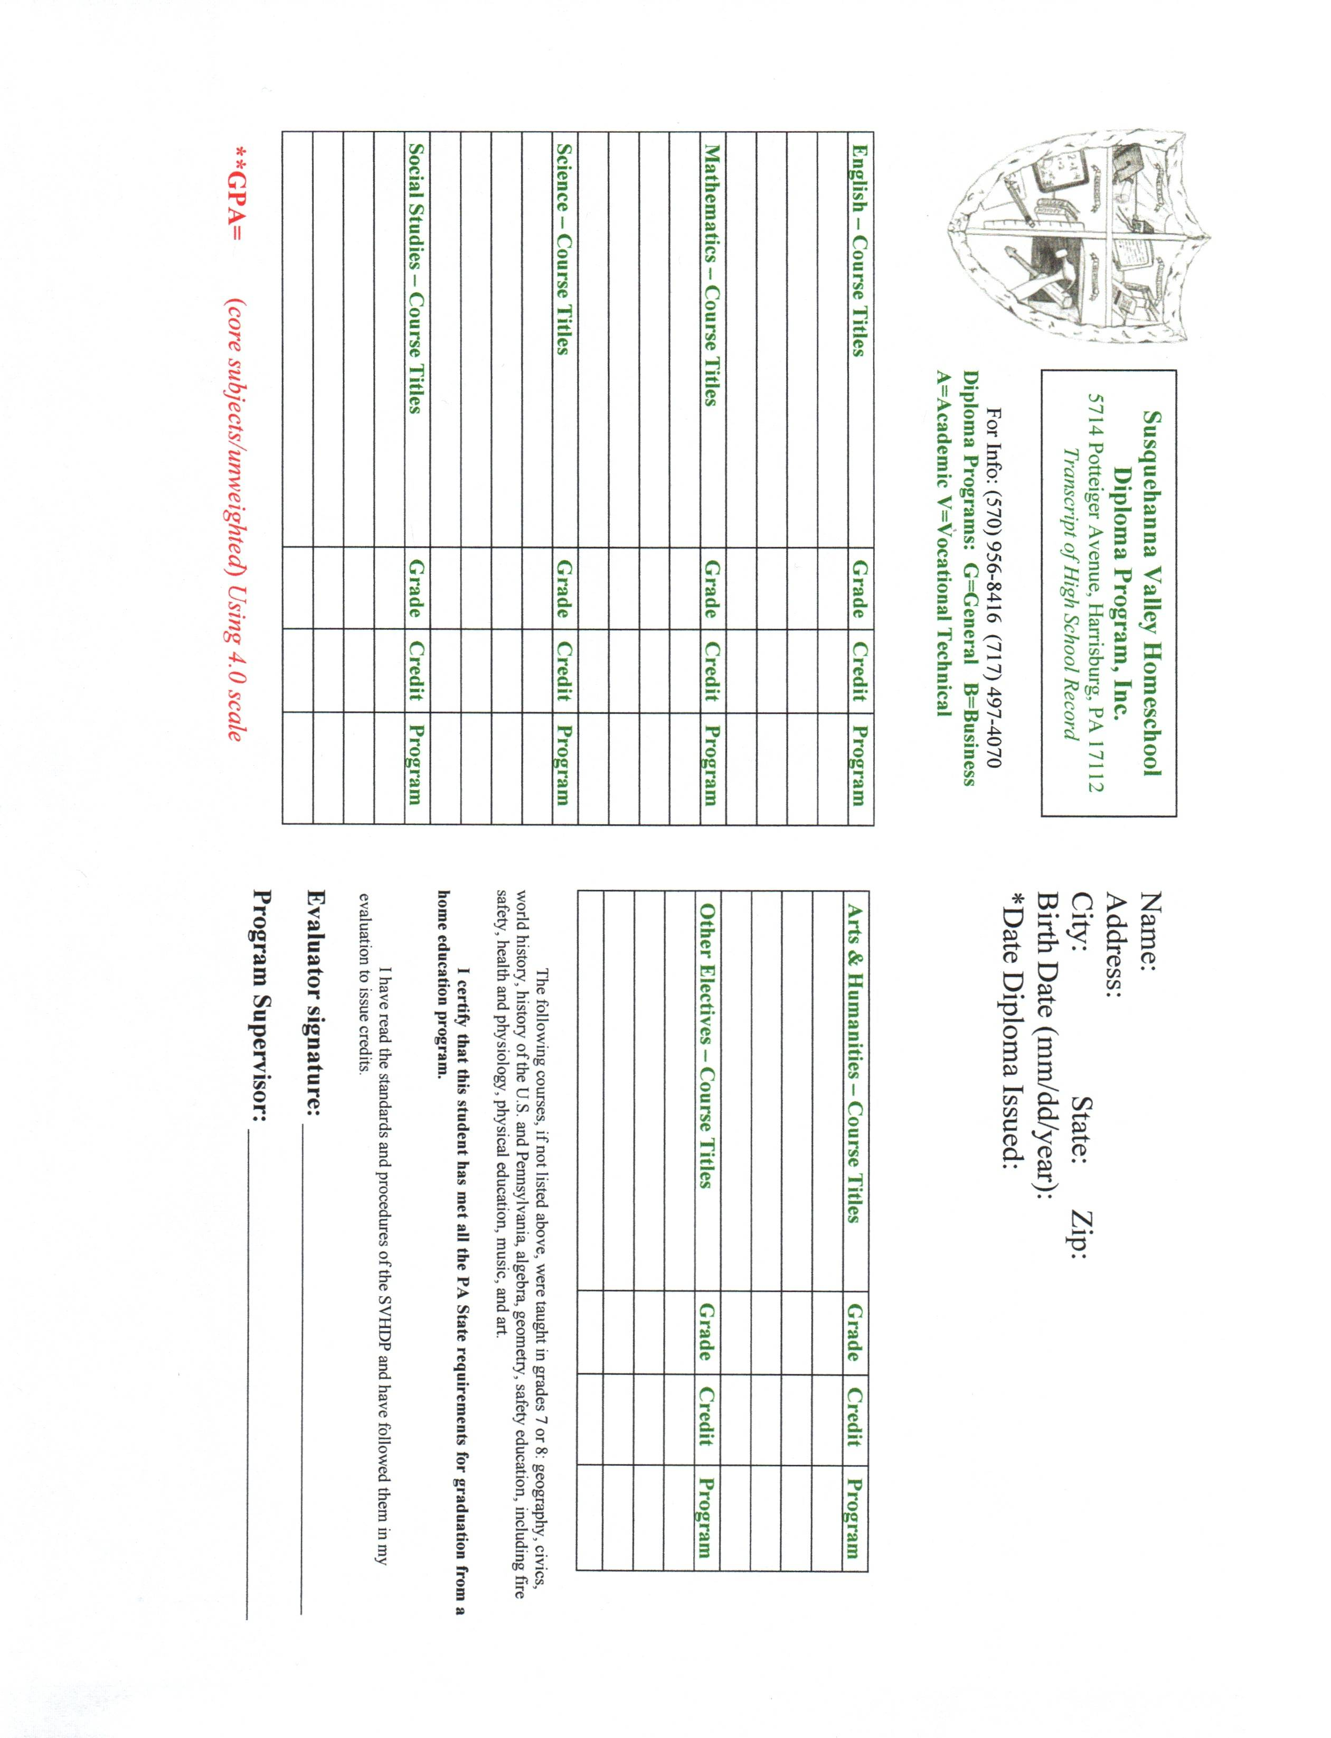
gjd

